Lab 3 Results:

1. Capture the screen with some valid measurements using the code and the potentiometer circuit. Share what the input voltage looks like and what your measurements say.

Input Voltage: 3.3V

The measurement show the variation of the conversions.

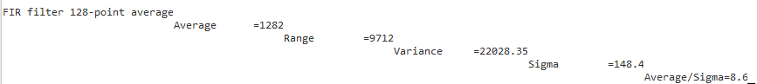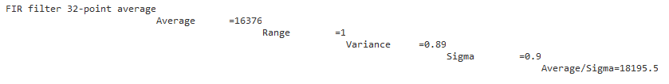

2) Capture the screen with some valid measurements using the code and a function generator. Share the input signal and why the data is the way it is.

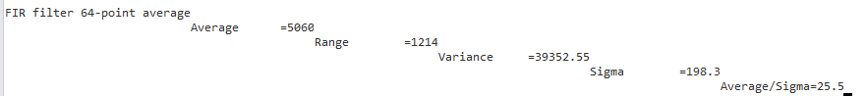

Input signal: Frequency:1.6

Range: 100

The signal is being converted for analog to digital resulting in a change in data.

3) a) What signal frequency would violate this systems Nyquist (sampling) Frequency?

According to the Nyquist Theorem, the sampling rate must be at least 2fmax, or twice the highest analog frequency component.

b) What is the voltage resolution of this system?

The voltage resolution of an ADC is equal to its overall voltage measurement range divided by the number of intervals.

c) What is the sampling inaccuracy of this system?

The advantages of a simple random sample include its ease of use and its accurate representation of the larger population.